Ultimate Syndicate Design Document Version 0.0.1
1. Abstract:

Syndicate was one of the greatest strategy games, largely due to the atmosphere and cleverness of design. Set in a dark, violent world of mega-corporate power and incredible technology. The civilians, having been brainwashed into believing that the world is wonderful, thanks to EuroCorp’s CHIP manufacture, lead relatively normal lives, not discouraged by the violence in the air.

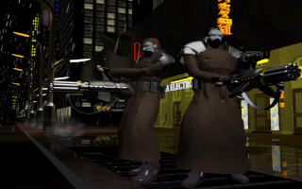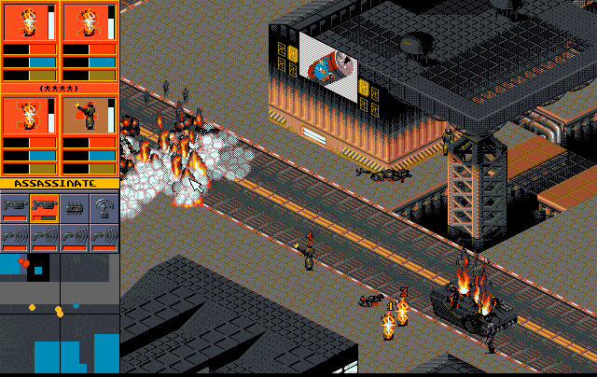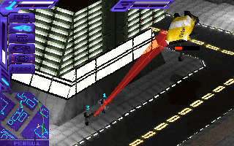
EuroCorp’s agents are doing the business.

The implementation is simple, using the mouse to control a handful of (usually cybernetically enhanced) agents; you must carry out a variety of missions. The ultimate goal? To take over the world. Naturally, this involves gunrunning, assassinations of important political figures, wiping out the resistance in the slums of the city, and best of all, persuading those who oppose you to join EuroCorp via the use of a brainwashing weapon, the Persuadertron. Great stuff. Each mission involves different objectives, and to further fund your Syndicate, you can tax the arse off your cities to provide research into new technologies and weapons.

The sequel, Syndicate Wars proved to have both improved on the original game, and yet also detracted from the original themes and ideas. Preferring to concentrate more on a shooter, rather than sharp thinking and ingenuity to defeat the enemies. One of the truly great things about Syndicate Wars was that it finally had a decent storyline, involving religious nutters and inner syndicate conflict. It also had a much larger variety of buildings, and vehicles, improving the general feel of the city; it felt like something out of Ridley Scott’s nightmares. Some may call it an improvement, many do not, but the most dramatic change in Syndicate Wars was the use of a 3D engine, which means that the city is viewable from 360 degrees, the viewer can zoom in and out, and see those agents which hide behind buildings. It seems to capture the “neon and steel” future well, although they do lack the ‘crispness’ of the original.

Anyway, both games are in need of a revamp. And in this document, I propose the ideas and technology to be used in the greatest Syndicate of them all, Ultimate Syndicate!
2. What do we plan to do with Ultimate Syndicate?

Hmm, I think the simple answer in here is “I don’t really know”. However, here are some simple ideas that some of us came up with.

- A rendered introduction sets the scene, with a delightfully scary, realistic cityscape. People are awaiting the arrival of an important public speaker. He appears, the impossible camera pulls back incredibly quickly to reveal a sniper hidden behind a pillar. A short beat. We hear the shot. Cut to the speaker, whose head now has a hole. Rock music begins to blare, The violence has began, 3 other agents, dressed in overcoats reveal miniguns and begin tearing apart the crowd. Police fire at the agents, ripping holes in their flesh. The agents ignore them until everyone in the crowd is dead and then without thinking twice, drop the empty miniguns and pull out a shotgun from the overcoat. <BLAM> <BLAM> The police fall. Arial shot, of the bodies and the agents, as a black stretch limo arrives, into which the agents enter.
- Or perhaps some kind of anime intro, like the sequence of Syndicate Wars on the Playstation, largely considered to be superior in some ways.
- High-resolution graphics (800x600 16bpp), with scalable architecture for those with smaller machines (P90’s etc).
- New artistic style, perhaps rendered, or hand-drawn.
- If rendered, render at high detail and scale the world to match. I really liked zooming out in Syndicate Wars and seeing the whole world crumble.
- Incredible detail.
- Newly restored and remixed soundtrack with stereo sound and sound effects.
- Fog, and light glare. (All optional, these don’t have an emphasis on play)
- A return to 2D graphics, although rotatable through 90 degrees, using the z and x keys on the keyboard.
- An incredible variety of civilians, all with their own agendas, and interpersonal relationships. (It’s going to be harder for me to tear them up now. ☺)
- New detailed buildings, banks, Apartments, Suspension bridges, Real railway systems™, Universities, Schools, Shops, Landmarks, Military Compounds, Police Stations. All destructible, given enough firepower or explosive.
- Also, the buildings are now enterable, and you can walk around inside them. Perhaps a different type of engine for this, or load different levels into mem when needed? (Ghost in the Shell millimetre view?)
- Vehicles, Cars of all different types, Harley Davidson bikes, Punk vehicles, Limos, Petrol Tankers (Shoot them, they leak fuel which you can ignite. BLAM!) Taxis, Buses, School Buses, SWAT vehicles “Railguns mounted on tanks”. You are not limited to the roads anymore too. Imagine driving a bus all the way up to a potential target, watching him freak out, just as he goes ‘squish’. Heh, nice.
- Things that change, given a different time of day, By day, people go shopping, go for walks in the “park”, go to work, use mobile phones. We can hear their conversations. People using the phone boxes, posting mail. Ambulances, Fire trucks all responding to the damage that you make. And you can steal them too!
- Retain most of the weapons of the original Syndicate, and just a few from the sequel. Those nice charge-up lasers!

Name of Weapon | Description
Pistol | A simple standard issue side arm
Shotgun | Powerful, but limited range
Uzi | Useful automatic side arm, good for eliminating police.
Minigun | Devastating rate of fire, powerful, but extremely heavy
Long Range Rifle | High range, decent firepower, but rate of fire is bad
Pulse Laser | Charge up firepower, with excellent power and good range.
Gauss Gun | Rocket launcher with explosive payload.
Flame Thrower | Useful for crowd clearance.
Nuclear Grenades | Tightly contained destruction and death.
Medikit | Rejuvenates a person to full health.
High Explosives | Excellent for laying traps, and destroying buildings.

- Upgradeable weapons, pistol goes to silenced, shotgun goes to automatic, flame-thrower releases more fuel per second, hence longer and more powerful jet of fire. Hmm, I'll think on this more.
- BONUS MISSIONS
- A fully armoured cyborg entering a police station, and blowing it all to shit, trying to eliminate a one Sarah Connor before she and her unknown colleague escape out the back.
- Working for Tyler Durden, you must infiltrate Microsoft Corp. and help rid the world of crappy bug-ridden software forever!
- Old Macdonald level with animals.
- Revisiting a level that you’ve already trashed with a tank, with working cannon! No real objectives here. Just have fun! Reduce the city to ashes. ☺
- The Persuadertron must be less powerful, it was much too easy to persuade vast numbers of people and then convert agents. If the enemy agents see a vast crowd, then it could fire on the crowd, and eliminate the potential persuasion problem. Special persuadertrons, costing much, much more to research and buy, can convert agents more easily, but it must still not be easy to do, especially if the enemy agent has high brainpower.
- Easily determine what modifications an enemy agent has, makes it easier for the player to co-ordinate attack, and similarly for the CPU opponents.
- More than one weapon carried by an enemy agent, although the only one dropped is the one that the enemy last used.

3 - Behaviour of civilians, Police and Enemy agents

Generally speaking, the world that EuroCorp inhabits is peaceful, thanks to judicious use of the CHIP, this means that the civilians are generally completely unaware of the violence and terror of the city.

3.1 – Civilian behaviour

I think the best way of programming the behaviour of the civilians would be, at run-time each civilian is given a set agenda, a list of instructions randomly generated, occasionally linking one another. Once a civilian runs out of instructions, the computer will automatically generate and issue new instructions.
Instruction 1
Go to city centre. (Or some location)
Instruction2
Wait for your “friend”
(Reference to another civilian)
Instruction3
Go to the shopping mall together, and talk.
An example behaviour generated by the engine at run-time.

We definitely must have some pre-defined special civilian behaviour, embedded in the map with a scripting language, instead of having them randomly generated. Like having them go to a building and wait for a political candidate. Very important, to create simple mission goals.

If some action occurs, like being told to move by a police officer, or to “Get Down!” Then this supersedes the list, and the civilian complies, or if a weapon is drawn, the CHIP jumps to panic mode, and administers drugs to assist in faster movement. Once the threat is over, and the civilian has requested police assistance (using their mobile phone!) the CHIP restores the civilian to normal, and returns to the list for instructions.

3.2 – Police behaviour

Police can follow three modes of AI. (Maybe more, I’m not that smart.)

- Patrol
- Await requests from civilians
- Guarding a particular location

Let’s elaborate on these AI’s further.

3.2.1) Patrol

Like a civilian, the police officer, either in a vehicle or otherwise, follows a generated list of instructions issued at run-time, involving moving around the city in some pre-defined pattern. If the police officer sees an armed person, (doesn’t have to be an agent, punks or suicidal civilians) then it breaks the list of instructions, pulls out his gun, and then threatens the armed person, and also calls for backup.

If a police officer is nearby and hears a call for backup/civilian help, then he responds by moving towards the call source.

3.2.2) Await requests from civilians/assistance

Mostly this will involve waiting in the police station, until it hears a call from a civilian or a radio call for backup from another police officer. Once this happens, the police officer is activated and travels to the source of the transmission.

3.2.3) Guard a particular location/person.

Even simpler than 3.2.2, all we have to do is make the police officers in question, stay beside the location or person and wait for trouble. If an agent appears armed, then these highly trained and armed police attack as a group.

3.3 – Enemy agent AI control

I plan to implement a Python scripting language, which will allow the programmer (and eventually – the end user.) to write their own basic AI’s for the game.

Some forms of AI,

- Idle
- Simple attack
- Overwhelm the player
- Use specific weapons for the job.
- Select the best position for attack as a team
- Retreat if the player is defeating you.
- Sneak attack.

3.3.1) Idle.
Do nothing until a player agent is visible and then simple mindless attack 3.3.2).

3.3.2) Simple mindless attack
Run towards the agent and fire with the best weapon you have.

3.3.3) Overwhelm the player.
Use many agents, and rush the player. Bunch up as a group and bring the agent down as fast as possible.

3.3.4) Use specific weapons for the job.
Using the correct weapons for the task at hand, Flame-thrower for a tight ambush, especially if the player does not have any cybernetic modifications. Use the gauss gun for players that move as a group – to eliminate them all together or to destroy the car that the agents are in, use the Minigun, laser or Uzi for stand off fights and simple assaults.

3.3.5) Select the best position for attack as a team.
This could be really hard… Let me think on it a little more ☹

3.3.6) Retreat if the player is defeating you and reform
Again, see 3.3.5)

3.3.7) Sneak attack
Hmm, stage an attack using a few agents in one direction. Then use different agents to attack from a different angle. Can be confusing and deadly for the player.
Agent’s primary attack.
Player’s agents
Sneak attack
4. - Vehicle control

There can be two main methods of control of Vehicles in Ultimate Syndicate; one is to use the mouse. The user would click on the part of the road where he needed to reach, and the agent would drive the vehicle there. Two modes are available, aggressive or non-aggressive. Aggressive means that the agent inside the car will occasionally break the laws of driving to get where you told him to go. Non-aggressive driving means that he will follow the precise rules of the road to get you to your destination.

The other method of driving would be for the user to take direct control of the vehicle, using a GTA style moving method. Up accelerates, Down slows down, and reverses, Left turns the steering left, and Right turns the steering right. Space will slam on the brakes. The user will not be limited to the roads, so if the user so desires, he can drive on the pavement, drive into a garage, slam into a building etc. Useful, although likely to attract the police and eventually SWAT team attention.

5 – Graphical Issues

Firstly, this game will NOT be using 3D acceleration or OpenGL, as it will be 2D only.

